AI STUDY BUDDY
AI Assistant for Smarter Learning and Study Support

Description:
AI Study Buddy is an AI-powered learning assistance platform designed to simplify the study process for students. The application combines modern web technologies with Generative AI to provide intelligent learning support.
The system allows students to upload or enter their study materials and use AI-based features to create useful educational resources. These features include concise summaries, flashcards, multiple-choice quizzes and personalized study plans.
One of the main components of AI Study Buddy is the integration of the Google Gemini AI API. The Gemini model processes the study content provided by the user and dynamically generates educational resources instead of depending only on predefined templates.

Background:
AI Study Buddy is an AI-powered learning assistance platform designed to simplify the study process for students. The application combines modern web technologies with Generative AI to provide intelligent learning support.
The system allows students to upload or enter their study materials and use AI-based features to create useful educational resources. These features include concise summaries, flashcards, multiple-choice quizzes and personalized study plans.
Scenario-Based Case Study:

Rahul is a second-year engineering student preparing for semester examinations while also learning technical skills for internship and placement opportunities. His study materials are available in different forms, including lecture notes, PDFs, textbooks, online articles and handwritten notes AI Study Buddy provides a centralized platform where Rahul can upload his study materials and use AI-powered features to generate summaries, flashcards, quizzes and personalized study plans.

Problem Statement:
The major problems faced by students are:
Difficulty understanding lengthy study materials within limited time.
Manual preparation of notes consumes considerable study time.
Creating flashcards and revision questions is repetitive.
Students may not have a personalized study schedule.
Study resources are not stored in a single centralized platform.
Students may find it difficult to evaluate their knowledge using self-created quizzes.
Using different applications for notes, quizzes and schedules can reduce productivity

Proposed Solution::
AI StudyBuddy provides a centralized AI-powered learning platform to automate common study-related activities.The study material is stored in MongoDB. When an AI feature is requested, the backend communicates with the Google Gemini AI service.
The system can generate:
- Concise summaries.
- Question-and-answer flashcards.
- Multiple-choice quizzes.
- Personalized study plans.

Usage

Student Usage:

AI Study Buddy is mainly used by students for improving their learning and study activities. Students can register and log in to the system, upload their study materials, generate AI-based summaries, create flashcards and quizzes, and prepare personalized study plans. Students can also use the multi-language translator to understand study content in their preferred language. The gamification feature helps students track their learning activities and progress. Students can save their important notes and export them as PDF for future reference and offline revision.

Administrator Usage:

The administrator is responsible for managing and monitoring the AI StudyBuddy system. The administrator can manage student accounts, monitor system activities, manage study-related content and features, and maintain the overall application functionality. The administrator can also manage available languages, gamification activities, and system settings. This helps to keep the application organized, secure, and useful for students. Software Requirements

Outcome:
AI StudyBuddy reduces the manual effort required to prepare study resources. Students can spend more time understanding concepts instead of manually organizing notes and preparing revision materials.
The integration of JWT authentication, MongoDB and Gemini AI provides secure and efficient management of learning resources.
Software Requirements:
Operating System: The application supports Windows 10/11, macOS and Linux.

Node.js: Node.js is used as the runtime environment for executing the backend server and application logic.
Npm: npm is used to install and manage the required Node.js packages and dependencies.

Express.js: Express.js is used as the backend web framework. It handles HTTP requests, routing and REST API operations.

MongoDB: MongoDB is used as the primary NoSQL database for storing user information, study materials and AI-generated resources.

Mongoose: Mongoose is used as the Object Data Modeling library for MongoDB. It provides schemas, validation and database interaction.
Thunder client: In This Thunder client is used to test and verify the REST API endpoints.

Visual Studio Code:Visual Studio Code can be used as the development environment for creating and managing the project files.

Hardware Requirements:
The recommended hardware requirements are:
Processor: Intel Core i5 8th Generation or above / AMD Ryzen 5 or equivalent.
RAM: Minimum 8 GB; 16 GB is recommended. Storage: Minimum 1 GB available disk space.
These requirements support the execution of Node.js, MongoDB and the application development environment.

Project Architecture:
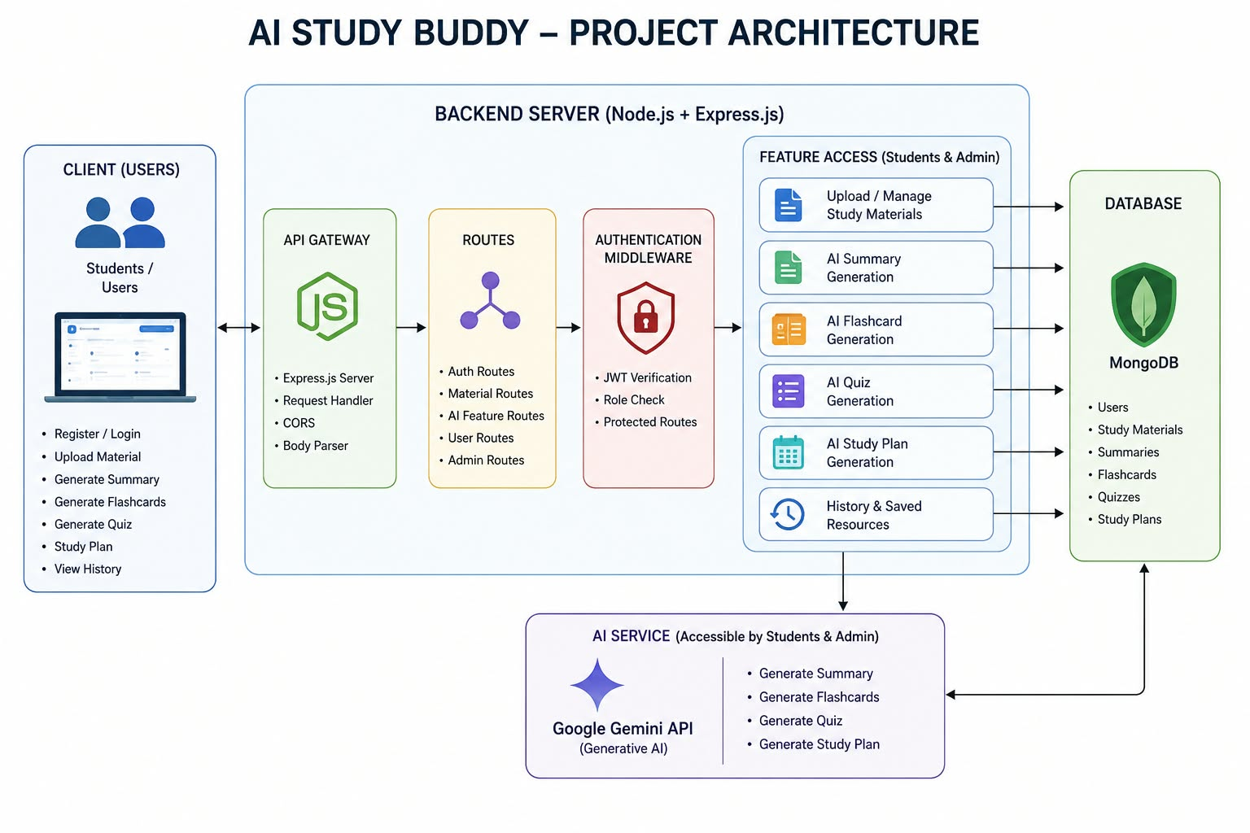
AI StudyBuddy follows a modular RESTful backend architecture.The frontend communicates with the Express.js server through REST APIs. The Express server receives requests and passes them to the appropriate route handlers.The backend communicates with MongoDB through Mongoose for storing and retrieving information. For AI-related operations, the backend communicates with the Google Gemini API.
The major components are:
Client Application → Express Server → Authentication Middleware → Route Handlers → AI Service / Database Layer

Components Definition:

Client Application:
The frontend allows students to register, log in, upload study materials and access AIpowered features.

Express Server:
The Express server receives HTTP requests, manages routes and sends responses to the client.
Authentication Middleware:
JWT-based authentication verifies users and protects private routes.

Route Handlers:
Route handlers manage APIs related to authentication, study materials, AI features and administration.

AI Service Layer:
The AI service communicates with Google Gemini API to generate summaries, flashcards, quizzes and study plans.

Database Layer:
MongoDB and Mongoose are used to store user details, study materials and generated learning resources.

Database Design:
The application uses MongoDB as its primary database.

Entity-Relationship (ER) Diagram Description:
The AI Study Buddy backend manages data through interconnected MongoDB collections that store user information, study materials, and AI-generated learning resources
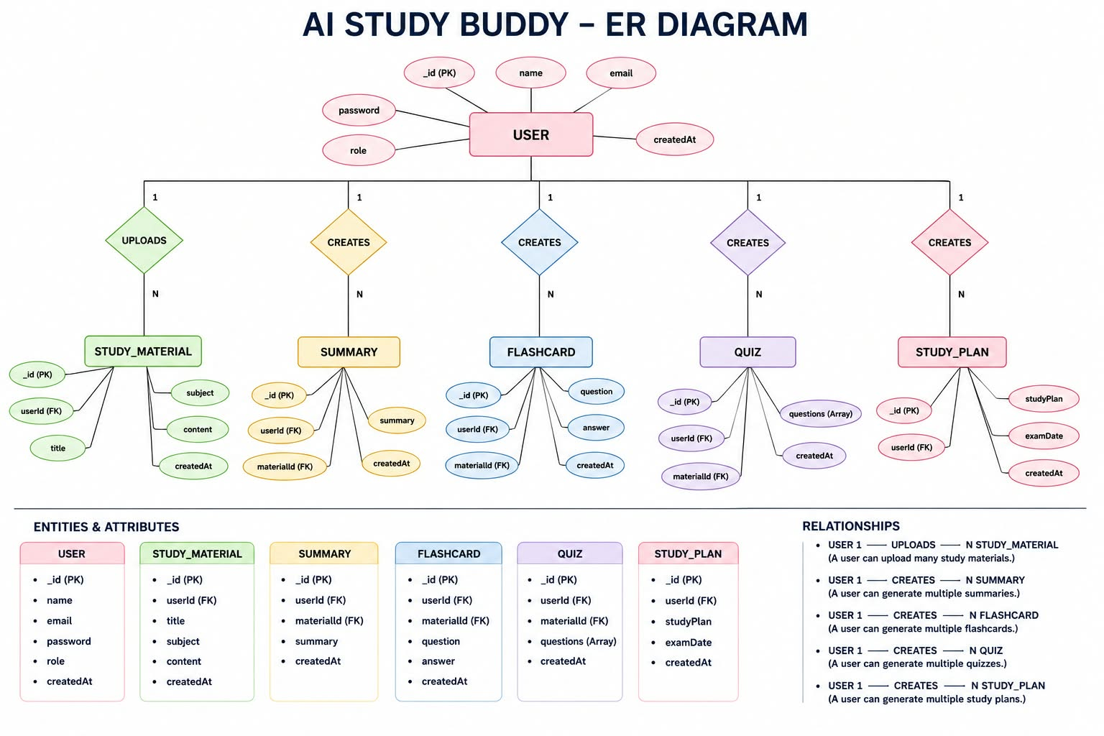

User Entity:
Stores registered student and administrator information.
Fields include:
-_id
-name
-email
-password role -created At

Study Material Entity:
Stores study materials uploaded by students.
Fields include:
-_id
-userId
-title
-subject content -created At

Summary Entity:
Stores AI-generated summaries.
Fields include:
-_id userId -materialId -summary -createdAt

Flashcard Entity:
Stores AI-generated flashcards.
Fields include:
_id userId materialId question answer createdAt
Quiz Entity:
Stores AI-generated quiz information.
Study Plan Entity:
Stores personalized study plans generated by AI along with examination date information.

Key Relationships:
The system contains several logical relationships between its entities.
-One user can upload multiple study materials.
-A study material can have an AI-generated summary.
-A user can create multiple study plans.
-AI-generated resources are associated with the user who created them.

Key Features:
Secure User Authentication:
The system uses JWT-based authentication to protect user accounts and private resources.
Password Security:
Passwords are protected using bcrypt/bcryptjs before storage.

Study Material Management:
Students can upload and manage study materials that act as input for AI processing. AI Summary Generation:
The system generates concise summaries from study materials.
AI Flashcard Generation:
The system automatically creates flashcards to support revision and active recall.
AI Quiz Generation:
The system generates multiple-choice questions based on study materials.

AI Study Plan:
The system generates personalized study plans based on the user's learning requirements. Role-Based Access Control:
Different permissions are provided for students and administrators.
MongoDB Storage:
User information, materials and generated resources are stored using MongoDB.

Roles and Responsibilities:

Student:
Students are the primary users of AI StudyBuddy. They can:
Register an account.
Log into the application.
Upload study materials.
Generate summaries.
Generate flashcards.
Generate quizzes.
Generate personalized study plans.
View previously generated learning resources.

Administrator:
Administrators manage the overall system. They can:

Manage registered users.
Monitor application activity.
Manage user accounts.
Monitor AI service usage.
Review system activities.
Maintain platform integrity.

User Flow:
The application begins with user registration or login.
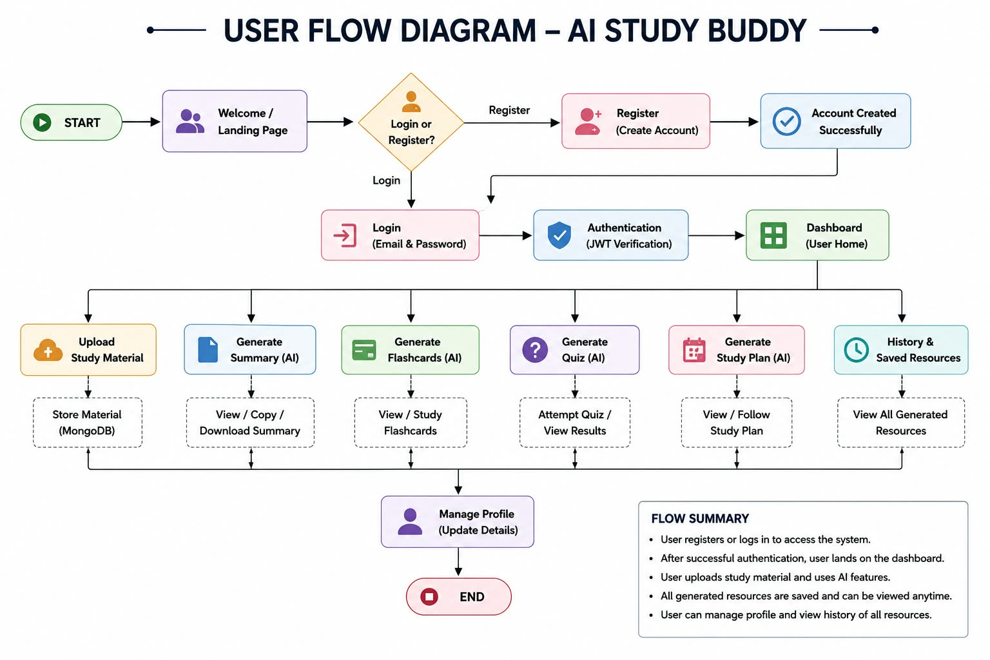
After successful authentication, the user is redirected to the dashboard. The student can upload study materials and select the required AI feature.The selected study material is processed by the backend.
Flow:
Register/Login → Authentication → Dashboard → Upload Material → Select AI Feature → Gemini AI Processing → Generate Resource → Display/Save Resource.

MVC Architecture:
AI Study Buddy follows the MVC architecture pattern.
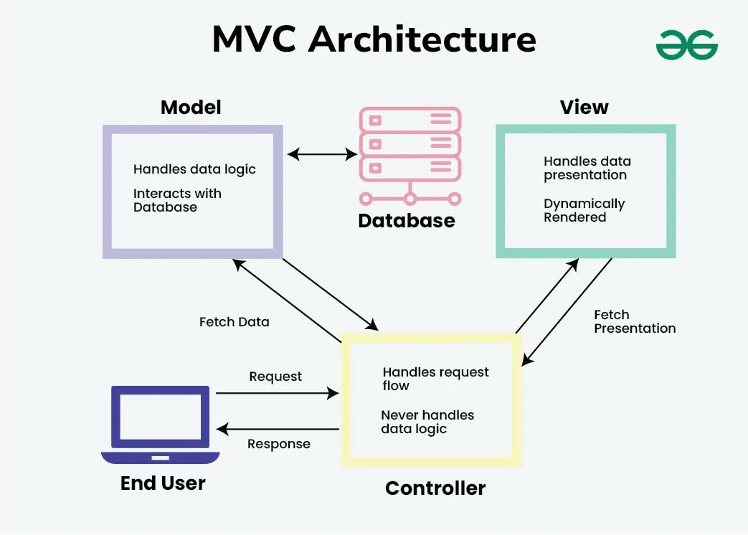

Model Layer:
The Model layer manages MongoDB collections using Mongoose schemas. It handles data validation and database operations.

View Layer:
Since the application works as a backend REST API, structured JSON responses are returned to the React frontend.

Controller Layer:
The Controller layer handles incoming requests, validates input, manages authentication and authorization, communicates with database models and calls the Gemini AI service when required.

Project Setup:
The project folder is created with the name AI StudyBuddy and opened in Visual Studio Code.The Node.js project is initialized using: npm init -yThe required dependencies are installed for Express, MongoDB, authentication, file uploads and Gemini AI integration.
Create the Following Folder Structure:
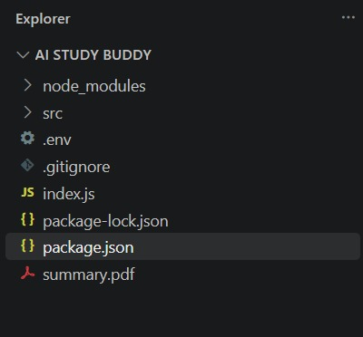

Environment Configuration:
The project uses an .env file to store configuration values.
PORT
MONGO_URI
JWT_SECRET
GEMINI_API_KEY
These values are used by the backend for server configuration, MongoDB connection, JWT authentication and Gemini AI communication.

Backend Development:
The backend is developed using Node.js and Express.js.The backend is divided into different modules such as:
Routes
Controllers
Middleware
Models
Database utilities
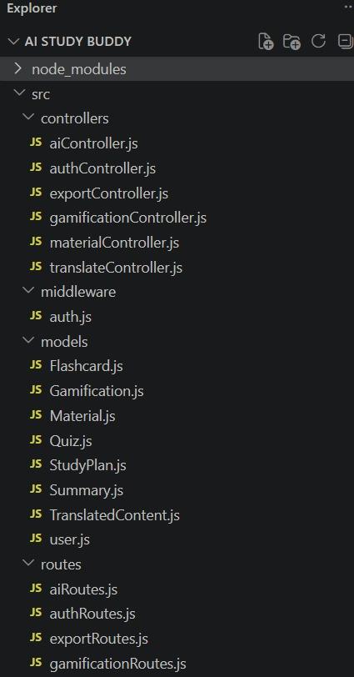
Gemini AI service

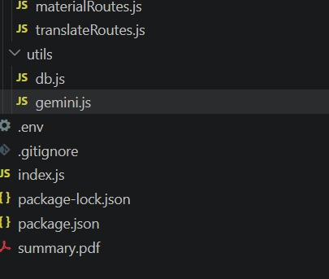

Core System Script Implementations:
Application Entry Point (index.js)
The index.js file serves as the main entry point of the application. It initializes the Express server, loads environment variables, configures middleware, establishes the MongoDB connection, registers API routes, and starts the server after a successful database connection.
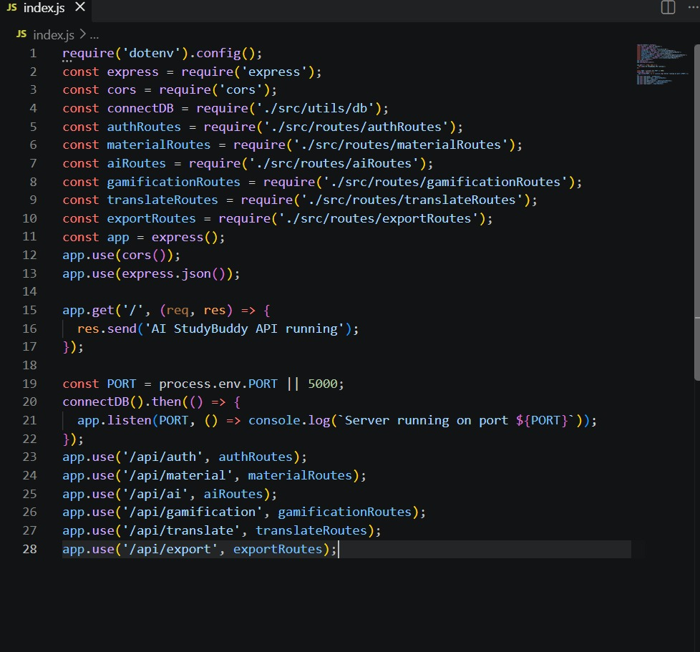

Database Connection:
The application uses Mongoose to connect the Node.js backend with MongoDB.The database connection is established before processing client requests. This allows the application to securely store and retrieve users, study materials and AI-generated learning resources.
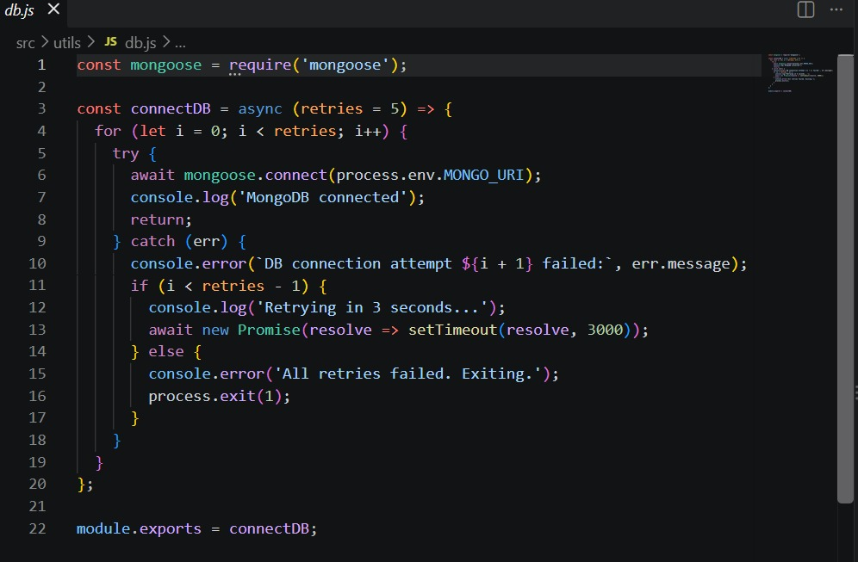

Authentication:
The authentication system uses JWT access tokens.When a user logs in successfully, the system generates a JWT token. The token is used to access protected API routes.The authentication middleware checks the token before allowing access to protected resources.
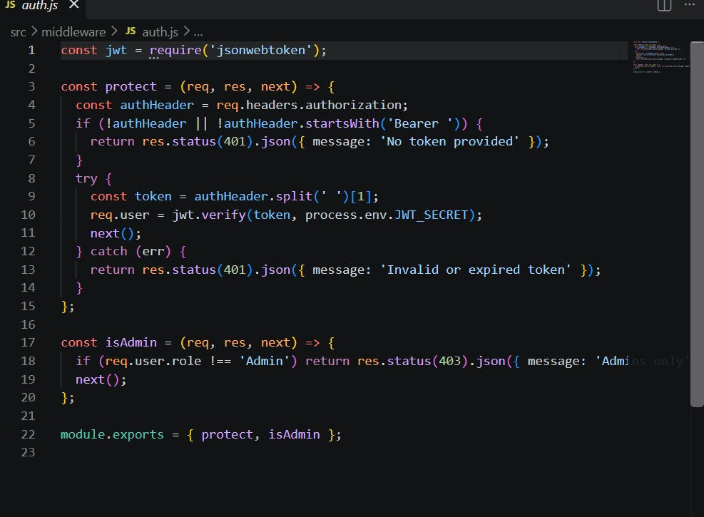

Gemini AI Integration:
The Gemini AI service is an important part of AI StudyBuddy.The backend sends prompts and study content to the Google Gemini model. The generated response is returned to the application and displayed to the user.
Summary generation
Flashcard generation
Quiz generation
Study plan generation
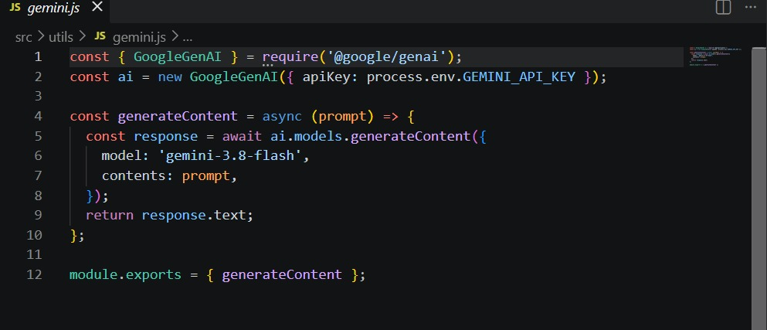
This allows the application to dynamically create learning resources according to the student's study material.

File Upload:
The application includes upload middleware for handling study material files.The upload middleware receives incoming files and validates them before they are processed by the backend. This allows students to provide study materials as input for AI-powered learning features.

API Route Interface:
The backend provides RESTful API endpoints for different operations.
Authentication APIs:
Used for user registration and login.
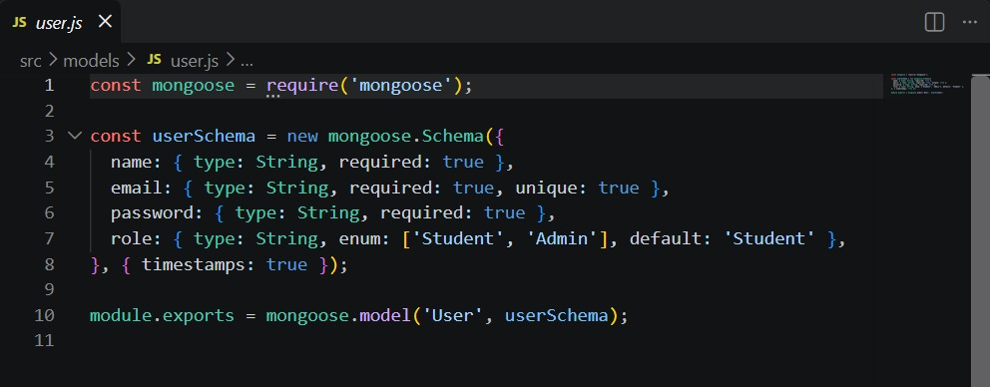
Study Material APIs:
Used to upload, retrieve, update and manage study materials.
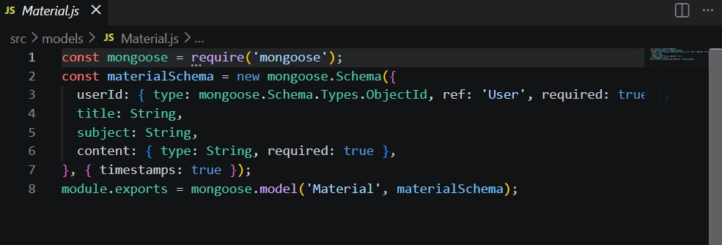

AI Feature APIs:
Used for generating:
AI summaries
AI flashcards
AI quizzes
AI study plans

Administrative APIs:
Used by administrators for managing users and monitoring system activities.

Project Execution:
The backend can be executed locally using Node.js.Before starting the application, MongoDB should be running and the required environment variables should be configured. The dependencies are installed using: npm install The development server is started using: npm start After successful execution, the server connects to MongoDB and starts accepting API requests.
Gamification:

Gamification is a feature that makes learning more interesting and engaging by adding game-like elements to the study process. In AI Study Buddy, students can earn points, badges, and rewards by completing study activities. For example, students can get points for completing quizzes, revising study materials, and following their study plans.
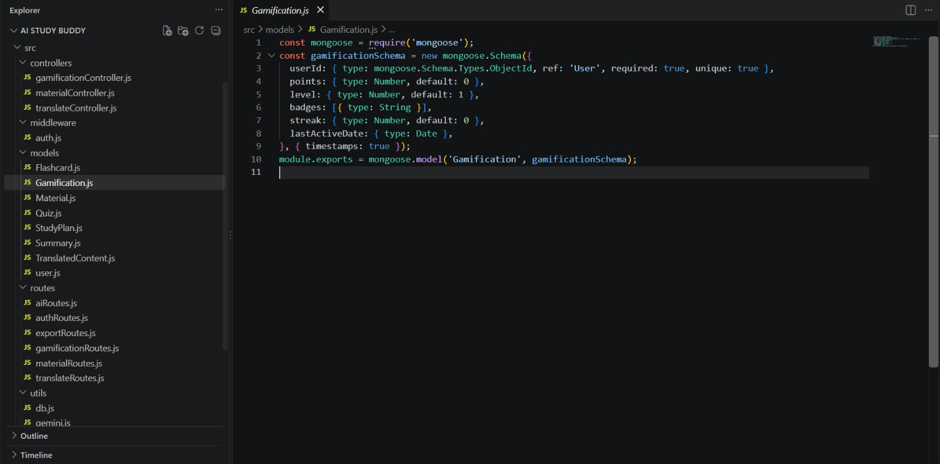

Main Features:
-Points for completing learning activities.
- Badges for achieving learning goals.
- Progress tracking for students.
Benefits:

- Makes learning more interesting.
- Encourages regular studying.
- Helps students track their progress.

Multi-Language Translator:

The Multi-Language Translator feature helps students translate study content from one language to another.
Students can enter or select study material and choose the required language.
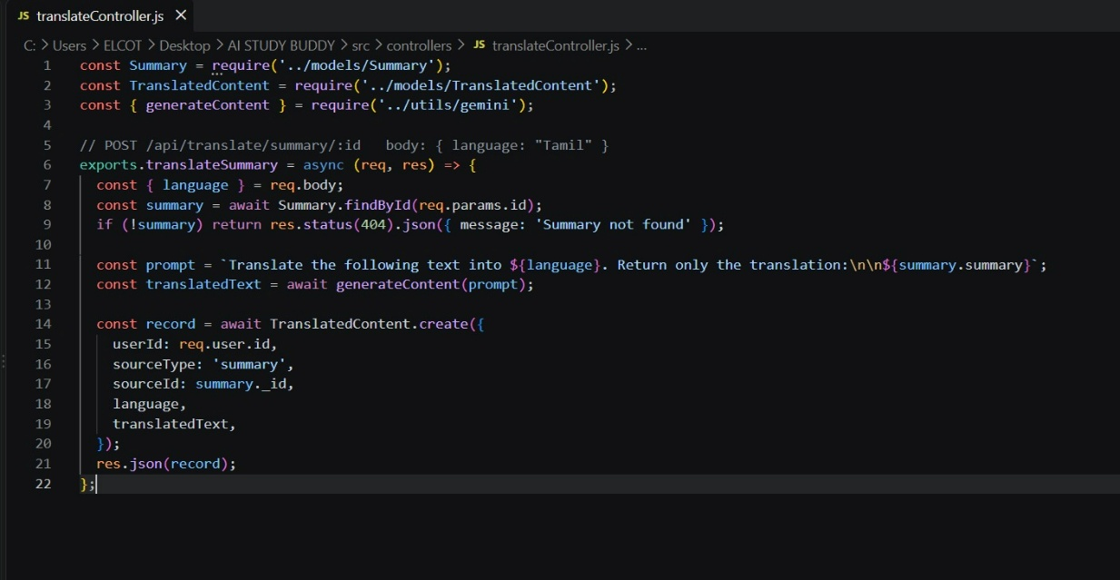

Main Features:
- Supports translation of study content.
- Allows users to select source and target languages.
- Helps students understand content in their preferred language.

Benefits:
- Improves understanding of study materials.
- Helps students learn in their preferred language.
- Reduces language barriers.

Export Notes to PDF:
The Export Notes to PDF feature allows students to save their generated notes and study content as a PDF document. After generating summaries, notes, flashcards, or other learning content, the student can export the required content into a PDF file. The PDF can then be stored or used for offline revision.

Main Features:
- Converts study notes into PDF format.
- Allows students to save generated notes.
- Provides an easy format for revision.

Benefits:
- Easy to save study notes.
- Useful for offline revision.
- Keeps notes organized.

API Testing:
The APIs can be tested using Postman or Thunder Client.

User Registration:
POST /API/auth/register
Registers a new user and securely stores the user's password.
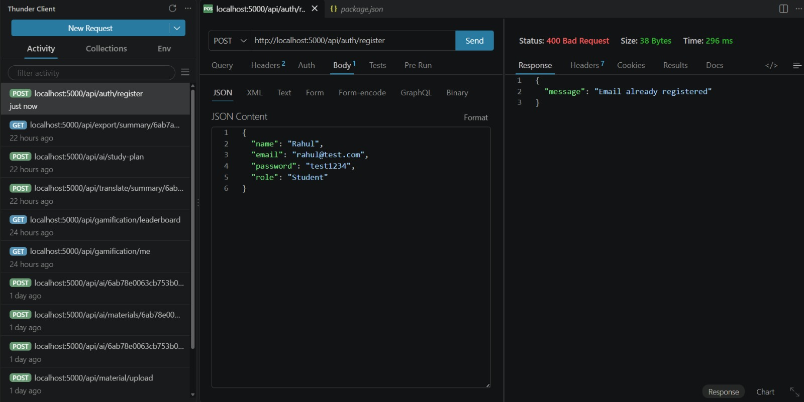

User Login:
POST /API/auth/login
Authenticates the user and generates a JWT access token.
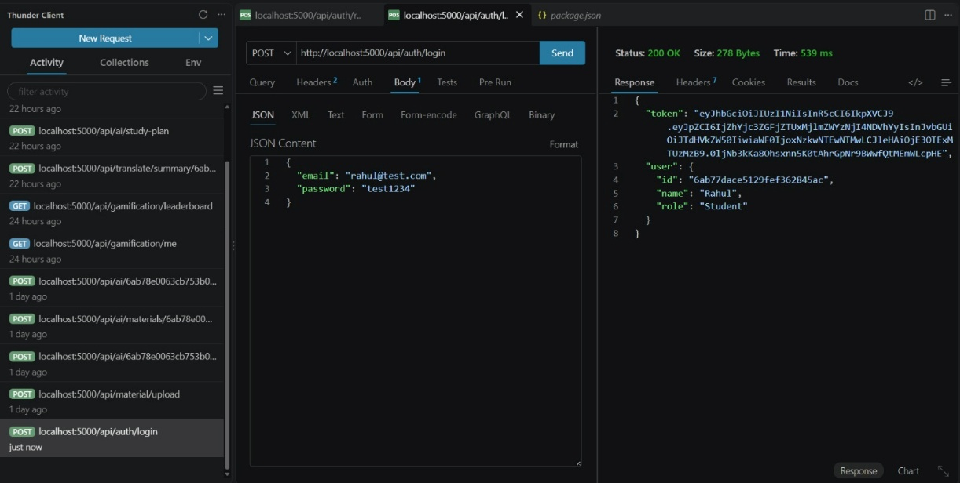

Upload Study Material:
POST /API/material/upload
Uploads study material for AI processing.
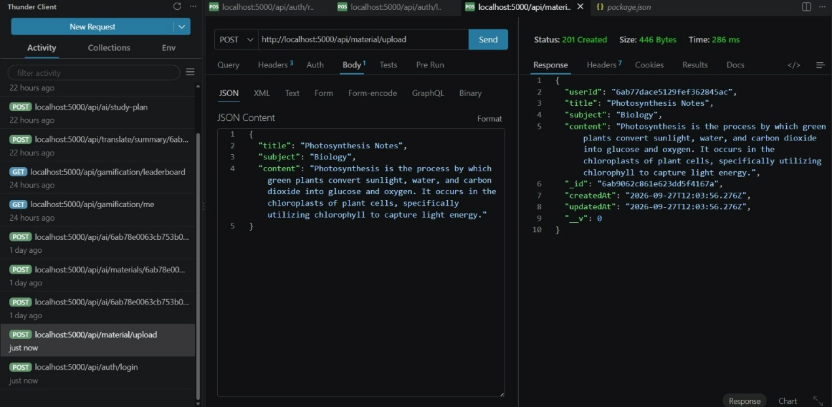

Generate Summary:
POST /api/materials/:id/summarize
Generates a concise summary from uploaded study material.
–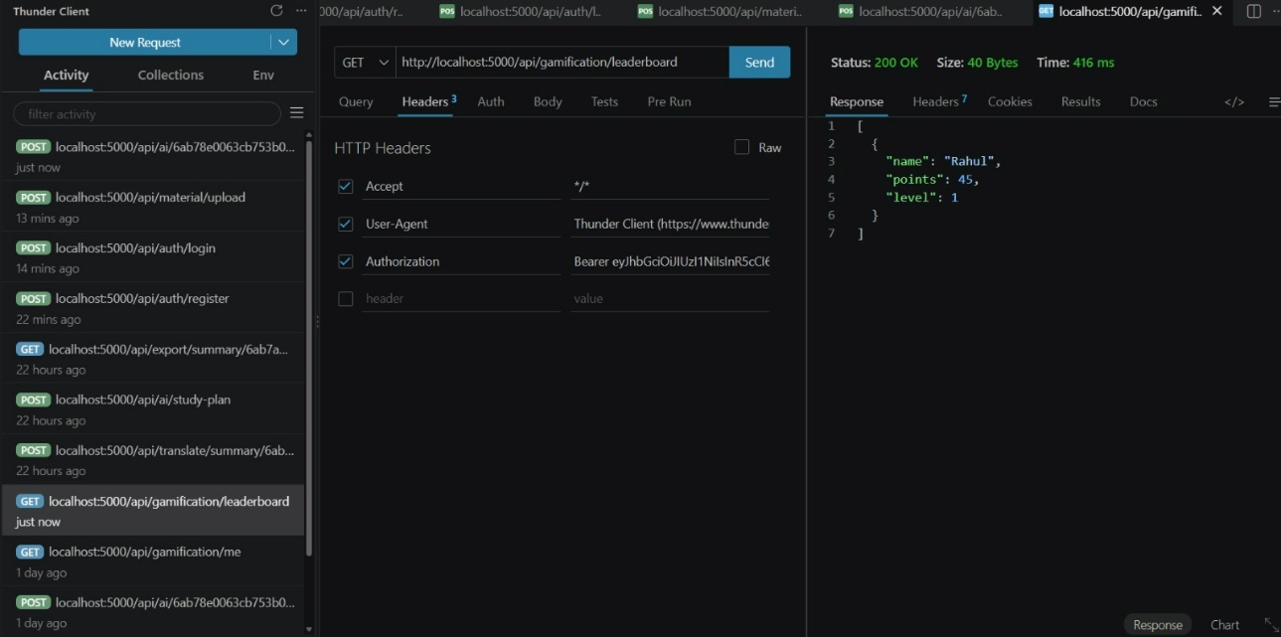

Generate Flashcards:
POST /api/ai/flashcards
Creates AI-generated flashcards.
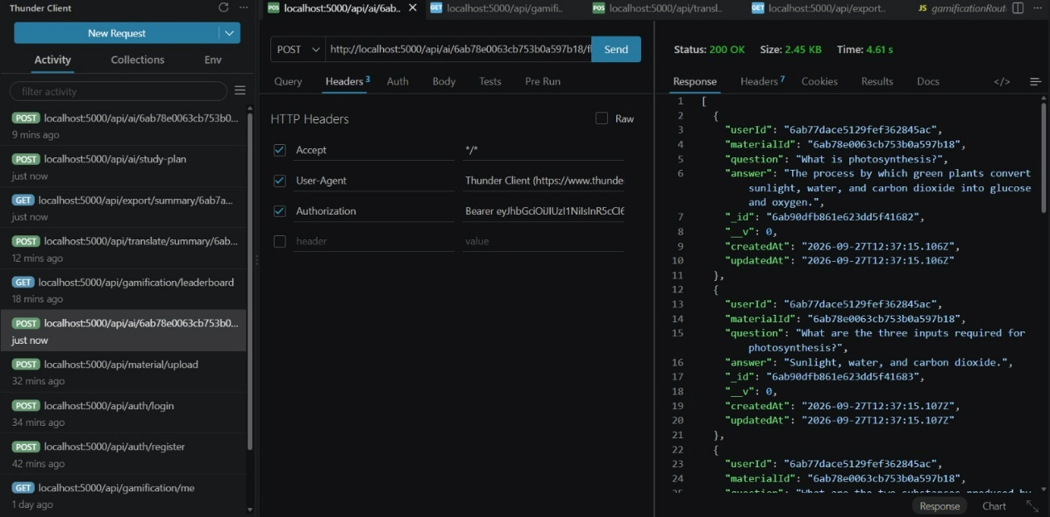

Generate Quiz:
POST /api/ai/quiz
Generates multiple-choice questions.
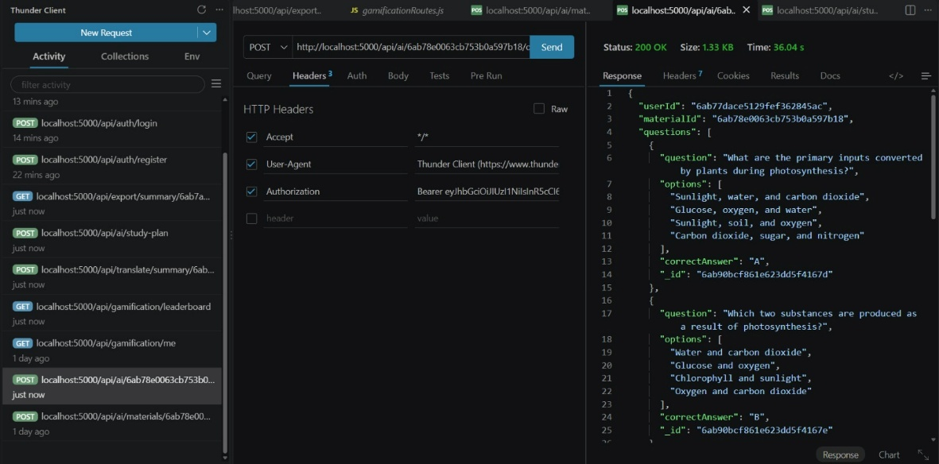

Generate Study Plan:
POST /api/ai/study-plan
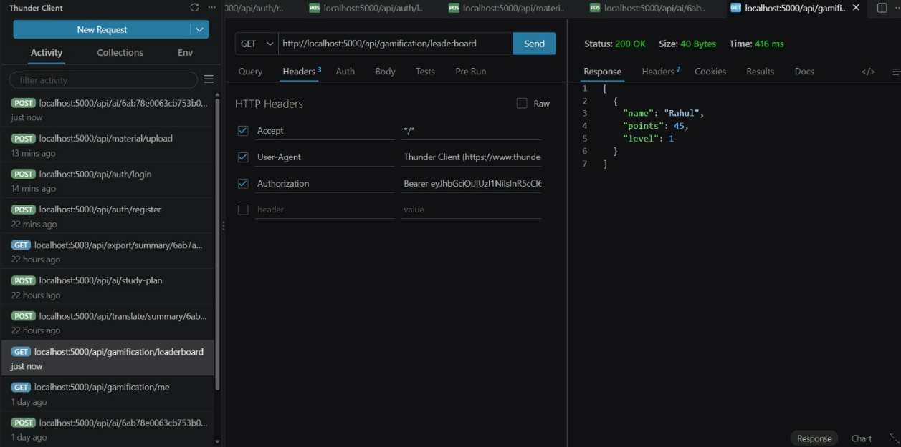
Creates a personalized study schedule.

Conclusion:
AI Study Buddy is an intelligent learning support platform designed to simplify academic preparation. It combines Node.js, Express.js, MongoDB, Mongoose, JWT authentication, bcryptjs and Google Gemini AI to provide a centralized learning environment.
Overall, AI Study Buddy provides AI-assisted learning support and helps students organize their study resources and revision activities in a single platform.

API TESTING LINK:
https://drive.google.com/file/d/16Eqj5N9gjaiDdP6DtinP6TTvMqXOj30U/view?usp=sharing
DEMO VIDEO LINK: https://drive.google.com/file/d/1g2vO_ezJPT9ityuqjb_860A7SmW_RWt1/view?usp=sharing

CODE: https://drive.google.com/drive/folders/1U2h6cwkytIYXuULzwKm0L4rbE4-ka1tM?usp=sharing

